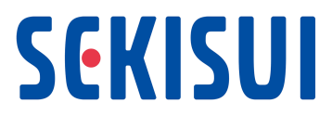

Sekisui Chemical Group Modern Slavery Statement for Financial Year (FY) 2022

This Statement sets out the steps taken by Sekisui Chemical Co., Ltd. in FY2022, ending March 31, 2023, as well as steps planned for in FY2023 and beyond.
This Statement additionally reports on the effect of the COVID-19 pandemic and the current situation at the time of writing.

- About this statement
Sekisui Chemical Co., Ltd. (hereafter referred to as the “Company”) makes this statement pursuant to section 54 (1) of the UK Modern Slavery Act 2015 (hereafter referred to as the “Slavery Act”). It sets out the actions taken by Sekisui Chemical Group, which is a corporate conglomerate managed by the Company as the parent company, to prevent any forms of modern slavery and human trafficking in any part of its business or its supply chains.
The Company hereby declares that it remains fully committed to opposing slavery and human trafficking in any part of its business or its supply chains. The concepts of slavery and human trafficking used in this statement are as defined in the Slavery Act.

- Outlines of our business and structure

Since its establishment in 1947, Sekisui Chemical Group has continued to open up new frontiers of “residential and social infrastructure creation” and “chemical solutions,” utilizing its prominent technology and quality, thereby contributing to enrich people’s lives and the social infrastructure. In 2001, we adopted the Divisional Company Organization System, which consists of three Divisional Companies and Headquarters.
Sekisui Chemical Group’s products are sold around the world. The Group, which has its head office in Japan, has 165 Group companies (excluding equity-method affiliates and affiliates) in 20 countries and regions. It has 26,838 employees and consolidated sales of 1 trillion 242.5 billion yen.

- Divisional Companies and Major lines of business
  - Housing Company
Major lines of business:
Housing, Stock Business, Town and Community Development,
Residential Services
  - Urban Infrastructure & Environmental Products Company
Major lines of business:
Pipe systems, Buildings and Infrastructure Composite Materials,
Infrastructure Renovation
Advanced materials
  - High Performance Plastics Company
Major lines of business:
Electronics, Mobility, Industrial
  - Headquarters
Life science and other businesses

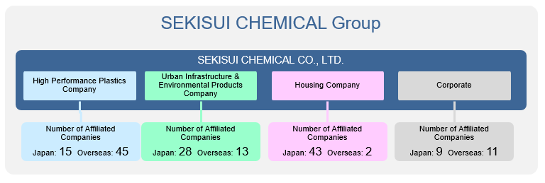

  - Business in the UK
In the United Kingdom, multiple companies that are part of Sekisui Chemical Group, including Sekisui Diagnostics (UK) Limited, are operating businesses.
Major lines of business: Manufacture and sales of enzymes, Clinical Chemistry and Coagulation systems & reagents, Infectious Disease Rapid Tests, Sales of polyolefin foam, etc.

- Outline of our supply chains

We source raw materials from suppliers across the world based on our Basic Procurement Policy. In FY2022, in order to respond to further social issues and demands that have arisen in recent years, including human rights, sustainability, and anti-corruption issues that have emerged with the diversification in social demands on the supply chain, we have formulated revisions to the Basic Procurement Policy.
In addition, we summarize list of items as standards which we request all suppliers involved with the Group and production of the Group’s products to comply with, as “SEKISUI CHEMICAL Group Sustainable Procurement Guidelines”. The Guidelines serve as the criteria that must be observed by all business partners involved with the Group and the production of its products, and include items on “compliance with the concepts and definitions of the Slavery Act”.
Furthermore, we ask our suppliers to take additional steps concerning risks that have been identified in relation to procurement of raw materials.

- Refer to: Sustainability Report 2023
- (p.346-347) SEKISUI CHEMICAL Group’s various policies > Basic Procurement Policy
- (p.326) Foundation Underpinning ESG Management > Responsible Procurement > Sustainable Procurement Guidelines (Supplier Code of Conduct)

- Overview of SEKISUI CHEMICAL Group’s Human Rights Initiatives
- Organizing our Human Rights Initiatives
SEKISUI CHEMICAL Group has organized human rights initiatives involving the Group based on the UN’s Guiding Principles on Business and Human Rights in the following manner. Grounded in the SEKISUI CHEMICAL Group Human Rights Policy formulated in May 2019, we will work to build a cycle to evaluate human rights impacts, integrate human rights into business, make reports, and establish a grievance mechanism in an effort to identify, address, and remediate any human rights risks that may arise from the Group’s business activities.

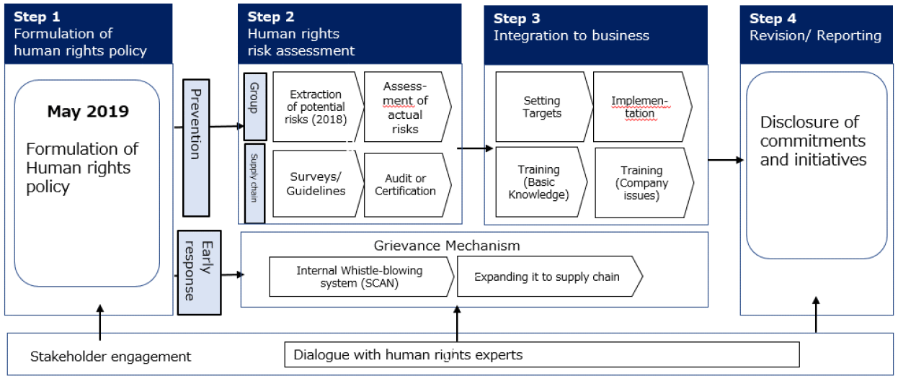

- System to Enhance Initiatives
To strengthen our response to a wide-ranging array of human rights issues, including identification, evaluation and remediation of human rights risks, education and training, and establishment of grievance mechanism, in a cross-organizational manner, we established the Human Rights Subcommittee under the Sustainability Committee in FY2022. Chaired by the Director, Executive Officer and Head of Human Resources Department, this subcommittee is comprised of the heads of each specialized headquarters department, and assumes the role of formulating Group-wide policies regarding human rights. At the same time, four working groups linked to the Human Rights Subcommittee plan and execute concrete measures.
Likewise, we promote our human rights initiatives throughout the Group by sharing the policies and measures established by the Human Rights Subcommittee and each working group among each of the relevant departments of the Company’s headquarters and divisional companies, and by applying these down to the business site level. In FY2022, the Human Rights Subcommittee met 12 times.

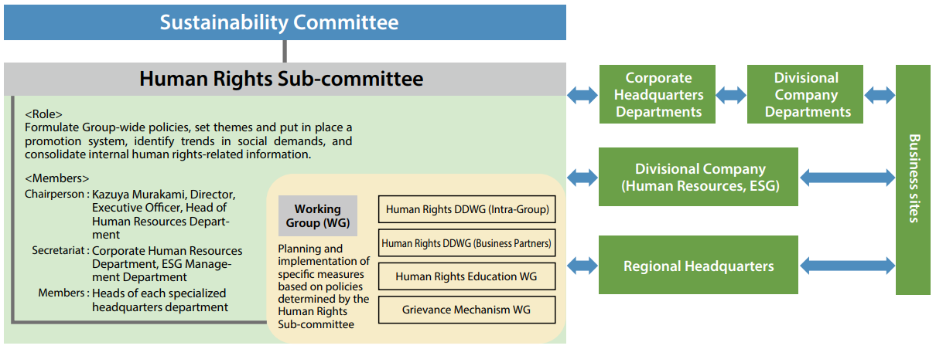

- Policies related to prevention of slavery and human trafficking

In May 2019, Sekisui Chemical Group drew up the Sekisui Chemical Group “Human Rights Policy”, based on the United Nations Guiding Principles on Business and Human Rights, to prevent all forms of slavery and human trafficking in our business and supply chains. The “Human Rights Policy” was adopted by the Board of Directors of the Company and signed by the President and Representative Director of the Company. The next steps will include thoroughly informing all employees and business partners of Sekisui Chemical Group about the
“Human Rights Policy” and fully implementing the Policy.
Sekisui Chemical Group “Human Rights Policy”
(Sustainability Report 2022 p.335-336)
In March 2009, Sekisui Chemical Group signed the United Nations Global Compact and, together with all of our Group companies, is supporting the Ten Principles of the UN Global Compact.

- Human rights risks and due diligence process
- SEKISUI CHEMICAL Group
SEKISUI CHEMICAL Group launched initiatives aimed at building a human rights due diligence framework in November 2018. Initiatives implemented up to fiscal 2022 are as follows.

・ From Fiscal 2018 to Fiscal 2019:
Employed a specialized agency (Verisk Maplecroft) to analyze potential
human rights risks in major businesses and conducted internal hearings based
on the results of analysis.

・ Fiscal 2020:
Implemented human rights interviews at domestic production sites.

・ Fiscal 2021:
Conducted a survey-format human rights risk assessment on a global basis for management in all areas where the Group is located and for general as well as indirect employees at selected business locations.

- Human rights risk assessment implementation method:
・ Survey format (two types: one for management and one for general employees)
- Targets:
・ Management in all areas where the Group is located (North and Central America, Europe, Asia, Australia). (Production sites: 44)
・ General employees in Thailand, China, and India and foreign nationality employees in Japan who were identified as high risk as a result of the latent human rights risk analyses and dialogue with experts conducted in 2018 (Both general employees and foreign nationality employees include indirect employees). (Production sites: 21)
- Objective:
・ Select priority human rights topics by conducting an exhaustive survey and gathering the opinions of both management and general employees
- Results:
・ Although no human rights issues requiring a critical or immediate response within the scope of the survey were revealed, priority human rights issues that were identified as requiring further review included working conditions for foreign nationality employees, fair wages, respect for religious practices, and inequalities in hiring and promotion.

・ Fiscal 2022:
Remediated issues identified through the above risk assessments, and implemented human rights interviews at two locations in Japan and overseas.

- Detailed initiatives of FY2022
・Identified and remediated human rights risk based on global human rights risk assessments
We confirmed the status of each situation on an individual basis for Group companies in Japan and overseas (total of six locations) at which issues were identified through the above human rights risk assessments. After formulating remediation plans to address the issues identified, steps were taken at five locations. (Remediation plan example: Draft employment agreements in workers’ native languages in order to promote an understanding of employment agreements among foreign nationality workers employed at Group companies in Japan). In regard to the remaining location, we laid out a remediation plan execution deadline of fiscal 2023, and will therefore continue to confirm its status.
・Human rights interviews with foreign nationality employees implemented at overseas production sites
We received comments during individual dialogue with overseas experts regarding the importance of conducting surveys as to whether overseas Group company migrant workers had suffered human rights violations. Similarly, as part of the human rights risk assessments conducted in fiscal 2021, we confirmed that many duties were being performed by Vietnamese migrant workers at a Group company located in Taiwan. In response, in fiscal 2022 we interviewed the Vietnamese employees for the purpose of investigating the actual labor environments of migrant workers within the Group.
- Targets
Vietnamese workers employed at Sekisui Industrial Piping Co., Ltd. (Taiwan) of the UIEP Company
- Implementation method
1) Conducted a survey of Vietnamese workers based on the Dhaka Principles, an international standard regarding the dignified immigration of foreign workers, as a preliminary review.
2) Based on the preliminary survey, Caux Round Table Japan* divided workers into groups of three or four, and interviewed each for around one hour.
3) Confirmed the living environment by observing the shared housing in which the Vietnamese workers live
- Survey content
Forced labor, freedom of association, the right to collective bargaining, equal pay, and prohibition of discrimination, etc.
- Results
Although this interview investigation did not reveal any notable negative impacts on the human rights of the Vietnamese migrant workers, it did identify preparing multilingual pay statements and internal factory signage, reducing the burden of living expenses, securing access to employee whistleblowing systems, and others as issues requiring priority action. In response to these issues, Sekisui Industrial Piping Co., Ltd. (Taiwan) formulated a remediation plan and will address these issues in stages.
・Human rights interviews with foreign nationality employees implemented at domestic construction sites
In light of frequent comments from Japan and overseas regarding the high level of human rights risk in Japan related to the general labor environment for foreign nationality employees, we conducted interviews at domestic production sites in fiscal 2020. Following-up on this effort, in fiscal 2022 we conducted foreign national employment management assessments*, including employee interviews, at construction companies of the Housing Company.
- Targets
1) Two foreign nationality employees working at SEKISUI HEIM KINKI CO., LTD. of the Housing Company
2) Personnel and labor management supervisors for the aforementioned foreign nationality employees
- Implementation method
1) Conducted a preliminary survey consisting of 342 questions in 40 categories regarding human rights, and held interviews with personnel and labor management supervisors based on the survey results
2) Conducted interviews with two foreign nationality employees
3) Took remediation action in regard to the assessment results and matters indicated by third parties (Remediation action example: Always verify whether supervisory organizations and registered support organizations are certified bodies when hiring technical intern trainees and specified skilled workers).
4) Received an A-rating as a result of the assessment, were recognized as a business in good-standing for appropriately employing foreign nationality employees, and acquired a Certificate in Appropriate Employment Company of Foreign National Employees.
- Results
Having received high marks in labor, job satisfaction, and other categories, our approach to employment and work hours as part of foreign national employment was judged to be appropriate. On the other hand, under the category of human resources management, despite having a foreign national human resources career development system in place to some degree, including systematic new employee training, systematic safety training, and Japanese language education, we received comments indicating issues regarding training with an outlook for medium- to long term work and specifying career paths. In the future, we plan to deploy assessments covering foreign nationality worker management for both Group companies and construction companies along the supply chain.
* This assessment is designed to confirm whether foreign national human resources are appropriately employed. Involved in foreign national human resources recruitment, foreign national employment support, and Japanese language education support, One Terrace Co., Ltd. serves as the certification organization.
- Refer to: Sustainability Report 2023
- (p.319-322) Foundation Underpinning ESG Management > Respect for Human Rights > Human Rights Due Diligence (SEKISUI CHEMICAL Group)

- Supply Chain
- Surveys on Sustainable Procurement
SEKISUI CHEMICAL Group conduct sustainable procurement surveys to assess whether our business partners are operating in a socially responsible manner. Based on the survey results, we work with our business partners to resolve any outstanding issues. In FY2021, we broadly revised the survey to include content that allows us to evaluate and confirm the compliance status and achievement status of the above Supplier Code of Conduct. Moreover, we began implementing the survey across the globe at the same time from fiscal 2021 in order to more rapidly address common global initiatives. As a result, we received responses from 67% of our suppliers that were subject to the survey.
In fiscal 2022, we conducted direct interviews with 13 companies with poor self-assessments on the above survey for the purpose of confirming whether there were any potential risks, and to confirm their situation. As a result, we determined that risk was low at 12 companies. In regard to one remaining overseas manufacturer, we conducted interviews of local workers together with consultants in order to reduce risks and advance efforts toward improvement.

- Refer to: Sustainability Report 2023
- (p.326-333) Foundation Underpinning ESG Management > Responsible Procurement

- Surveys on Raw Materials (Timber and Conflict Minerals)

- Surveys on Timber Procurement

We significantly updated our existing due diligence procedures in FY 2022.
Specifically, we have set a new target of 2030: Zero Deforestation and revised our Timber procurement policy to achieve this goal.
We have launched initiatives to reduce the negative impact of deforestation on the human rights and environment of indigenous peoples, performing legal timber procurement to date as a matter of course.
The details of these initiatives include conducting questionnaire surveys of 57 suppliers in regard to tree species and logging areas, holding interviews with suppliers among these 57 who handle raw materials that are endangered species and that are from countries with high-risk logging areas, and clarifying traceability. We will continue to engage in efforts to reduce identified risks.

- Refer to: Sustainability Report 2023
- (p.347) SEKISUI CHEMICAL Group’s various Polices > Basic Procurement Policy > Timber Procurement Policy

- Surveys on Responsible Mineral Procurement

In fiscal 2022 we conducted surveys based on the newly revised Responsible Mineral Procurement Survey Manual. In advance of these surveys, we held in-house training sessions to deepen the understanding of the surveys in regard to the background behind conflict minerals (minerals used by armed insurgents as a source of funds) to be surveyed and social changes (child labor and other human rights violations).
Upon surveying 35 domestic locations and 16 overseas locations that handle the surveyed minerals, of those raw materials containing the surveyed minerals, in Japan the results identified 90% at smelters, while 5% were undisclosed and 5% were unknown. Overseas, the results identified 78% at smelters, while 2% were undisclosed and 19% were unknown. In fiscal 2023, we will investigate actions in line with the risk levels of undisclosed and unknown raw materials.

- Refer to: Sustainability Report 2023
- (p.330) Foundation Underpinning ESG Management > Fiscal 2022 Responsible Mineral Procurement Survey

- Establishment of a Hotline
The Sekisui Chemical Group establishes a variety of mechanisms to listen to opinions of stakeholders, such as reporting systems for employees and business partners, customer consultation office, and a sustainability inquiry desk, in order to take appropriate action to remediate any negative impact on human rights that may occur in its business activities. In 2002, Sekisui Chemical Group established the in-house whistleblower system called Sekisui Compliance Assist Network (S.C.A.N.), which can be used by any employee of the Group. Globally, we are proceeding with expanding the establishment of reporting points of contact to major overseas areas. So far, we have deployed the system to all areas except for Australia, which we aim to complete the establishment in FY2023.
In FY2015, access to S.C.A.N. was also expanded to executive officers and employees of business partners in Japan that transact with the Group.

- Refer to: Sustainability Report 2023
- (p.75) Governance (Internal Control) > Legal and Ethical Issues > Promotion and Operation of the S.C.A.N. Intra-company Whistleblowing System

- Education about slavery and human trafficking

- Human rights training programmes for Group employees
SEKISUI CHEMICAL Group conducts training and educational programs focusing on the theme of human rights for its employees. In this manner, the Group is endeavoring to engage in management that takes into consideration concerns regarding human rights. Training, especially at such milestones as when an employee enters the Company or is promoted, is designed to raise awareness of human rights issues including forced labor, child labor, and harassment, thereby promoting the importance of respecting human rights and our human rights policy. Moreover, as part of our human rights education for employees in Japan and overseas, we began our Business and Human Rights e-Learning course in Japanese and English, which is available on the Company intranet, from fiscal 2020. In fiscal 2022, we prepared versions of the course in German, Spanish, Dutch, Chinese, Thai, and Indonesian, and expanded this initiative to employees in all areas (North America, Europe, and Asia) in which the Group operates. Through these training and education means, we are advancing awareness toward the importance of and need to respect human rights as well as our human rights policy.
- Implemented SEKISUI CHEMICAL Group Human Rights Week
In order to provide awareness-raising opportunities that enable employees to act with respect for human rights, since fiscal 2022 we have organized SEKISUI CHEMICAL Group Human Rights Week (slated for the week of December 4 to December 10 in conjunction with December 10 as the date the Universal Declaration of Human Rights was adopted) as a new initiative. As part of the first such event, the president released a message indicating the Group’s stance on respecting human rights. At the same time, we displayed our Human Rights Poster to encourage each individual employee to question whether they have violated the human rights of any individuals involved in their everyday work, including colleagues, business partners, and customers. We translated the message from the president into 11 languages, and prepared the human rights poster in Japanese and English before distributing it to all areas in which SEKISUI CHEMICAL Group operates.
- Refer to: Sustainability Report 2023
- (p.323-324) Foundation Underpinning ESG Management > Respect for Human Rights > Human rights education

- Engagement with external stakeholders
In April 2022, as members of the Human Rights Subcommittee, the Director, Executive Officer, and Head of the Human Resource Department along with the heads of each specialized headquarters department met with outside experts (Caux Round Table Japan) to exchange opinions regarding social demands involving Business and Human Rights and the Group’s related initiatives.
Through their exchange of opinions with the experts, the members learned about the latest trends in social demands on companies in regard to human rights, and received opinions on SEKSUI CHEMICAL Group human rights initiatives and advice on how to best develop our related activities moving forward. We will systematically promote human rights activities in accordance with the Guiding Principles on Business and Human Rights, while taking into consideration the views of external experts obtained from the above engagement.

- Refer to: Sustainability Report 2023
- (p.325) Foundation Underpinning ESG Management > Respect for Human Rights > Stakeholder Engagement

- Plans for the future

Based on the perspective of the Guiding Principles on Business and Human Rights, we will strive to ensure that our business and supply chain do not cause or contribute to human rights abuses. In FY2023, we will identify the following three points as important measures concerning "Business and Human Rights".

- Fostering and spreading a culture of respect for human rights
To ensure that all employees are aware of the human rights policy and that a climate of respect for human rights is fostered throughout the Group, we will develop and implement measures to disseminate the policy to employees through the following initiatives.

- Raise awareness on "Business and Human Rights" throughout the Group
Hold Human Rights Month in all areas where the Group operates in order to raise the level of understanding of human rights throughout the Group.
- Raise level of understanding by management and executives
Conduct trainings and lectures for executive officers and Group executives to increase understanding among senior management.
- Incorporate into existing training
Incorporate human rights-related content into existing training programs, such as training by job level, and promote human rights initiatives that are integrated into business operations.

- Implementing human rights due diligence and reducing risks
- SEKISUI CHEMICAL Group
Conduct human rights risk assessments, including employee interviews, at construction and nursing care sites and production sites in Asia where high potential human rights risks have been identified within the group.

- Our Suppliers
Promote improvement initiatives with high-risk suppliers interviewed in FY2022, and establish a new risk management method to more accurately identify suppliers with a high degree of impact (negative impact on society and on the Company).

- Grievance Mechanism
Establish a multilingual global hotline and promote awareness of the hotline among non-Japanese employees and business partners.

- Addendum: On the effect of COVID-19
Although not required under the scope of the Statement, this section has been added as an addendum to the Statement. COVID-19, which was declared a pandemic by WHO in March 2020, has had an impact on our business activities as well as our supply chains. Sekisui Chemical Co., Ltd. and its Group companies in Japan are following the guidelines of the Japanese Government, while overseas business sites follow guidelines of their respective governments, working to ensure the safety of all of our workers and to sustain and continue our business activities.

This statement was adopted by the Board of Directors of the Company and signed by Keita Kato, President and Representative Director of the Company.

September 11th, 2023
Keita Kato
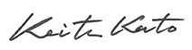
President and Representative Director
Sekisui Chemical Co., Ltd.

