The performance of this method, Acetaminophen 03R11 (y) was compared with the performance of Acetaminophen 2K99-20 at an external laboratory on the Architect c8000 (x). A combination of 57 natural and spiked patient serum samples ranging from (02K99: 3.8 – 340.7 µg/mL, 03R11: 4.3 – 368.9 µg/mL) spanning each assay’s measuring interval (3 – 377 µg/mL) gave a correlation coefficient of 1.000. Linear regression analysis gave the following equation:
This method = 1.079 (reference method) + 0.5266 μg/mL (3.5 μmol/L).
Figure 1 below displays the feasibility method comparison fit (Figure 1a) and difference plot (Figure 1b) of Acetaminophen Part number 03R11 versus Acetaminophen Part number 02K99 on the Architect c8000.

The data was fit using a Passing-Bablok regression analysis (Figure 1a). The slope, y-intercept, and correlation coefficient (R²) are 1.079, 0.5266, and 1.000, respectively. These parameters meet the acceptance criteria for the slope (1.0 ± 0.1) and R² (≥ 0.975). This fitting was performed according to CLSI EP09-A3.¹ The only exception to the EP09 protocol was the spiking and dilution of more than 20% of the total number of unmodified patient samples.
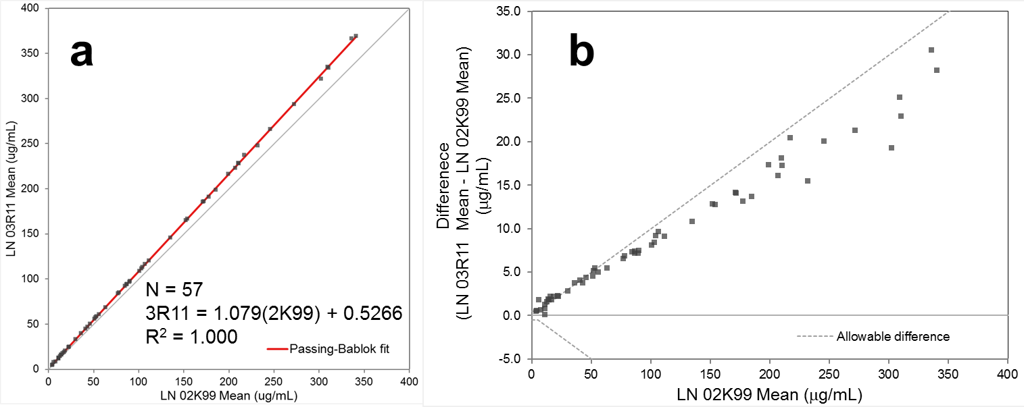
Figure 1. (a) Passing-Bablok fitting of method comparison data for part number 03R11 versus part number 02K99. (b) Difference plot displaying the difference (03R11 – 02K99) between the means of the two assays versus part number 02K99.

